**2021 TO 2022 AP PROBABILITY AND STATISTICS SUMMER ASSIGNMENT**

**Instructor: Ms. Kathleen Bunce Room 145**

**Email:** [**kbunce@jacksonsd.org**](mailto:kbunce@jacksonsd.org)

**Google Classroom Code:** [**https://classroom.google.com/c/MzU1NTQ5NTc0MDUw?cjc=5njvojh**](https://classroom.google.com/c/MzU1NTQ5NTc0MDUw?cjc=5njvojh)



AP Statistics is a rigorous and demanding course.  You must have the dedication to work very hard every day, both independently and in a group.  AP Statistics is a college–level course designed for you to earn 3-4 college credits. The summer assignment covers the material in the preface and Chapter One of the textbook. The textbook we will use is, “The Practice of Statistics 6th Edition”. I will post the instructional videos and the textbook pages on the Google Classroom page. This assignment must be posted to google classroom by the first day of class.

Enjoy your summer and I look forward to working with you!

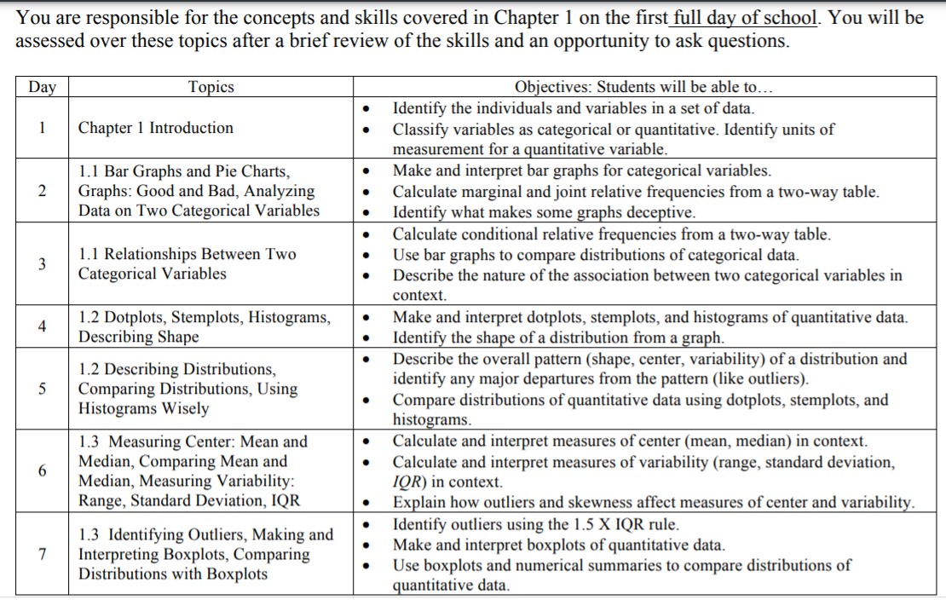

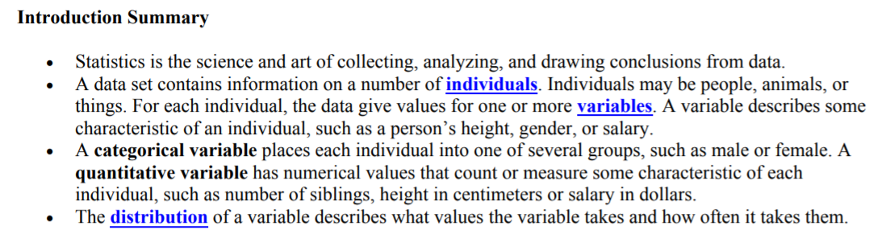



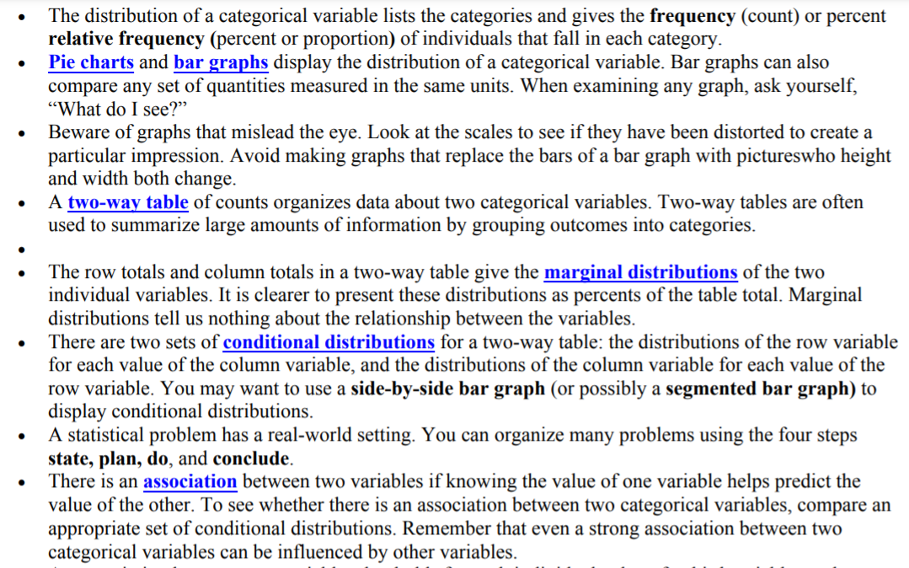



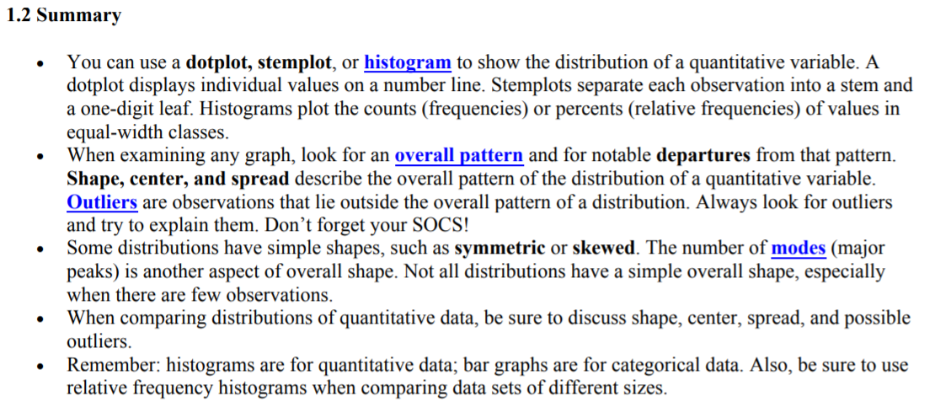

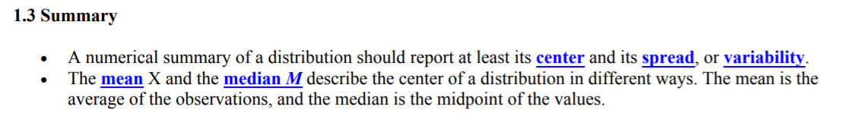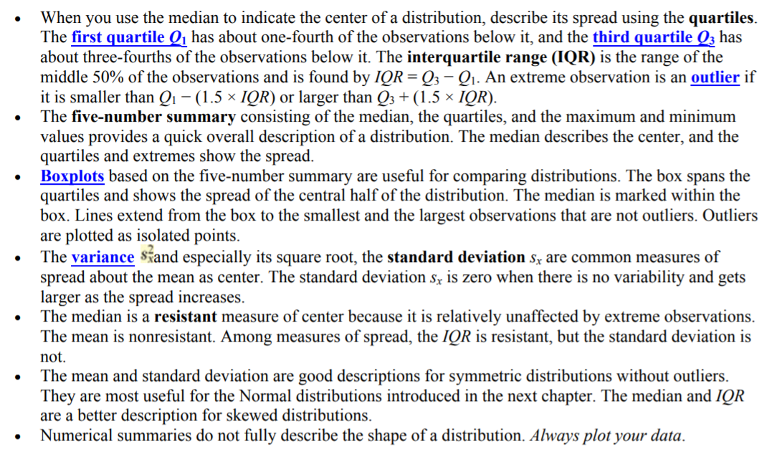

**Assignment:**

**Watch the following YouTube Video on “Why Study Statistics” at the following link:** [**https://www.youtube.com/watch?v=cIZzl_QS7YA**](https://www.youtube.com/watch?v=cIZzl_QS7YA)

**Write a one-page summary highlighting key reasons to study Statistics.**

